SLT - Set If Less Than Instruction

Java code:

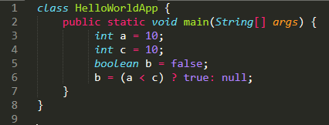

Description:
Init variables “a” & “c”. Set “a” & “c” to 10. Set b true if a is less than c.

MIPS
slt $s0, $s1, $s2

Description:
Instructions for line 6. $s0 = b, $s1 = a, $s2 = c.
Set register $s0 to 1 if value in register $s1 is less than value in register $s2.

Special | $s1 | $s2 | $s0 | 0 | slt
000000  6 | 10001  5 | 10010  5 | 10000  5 | 00000  5 | 101010  6

Binary: 00000010001100101000000000101010
Hex: 0x0232802A

